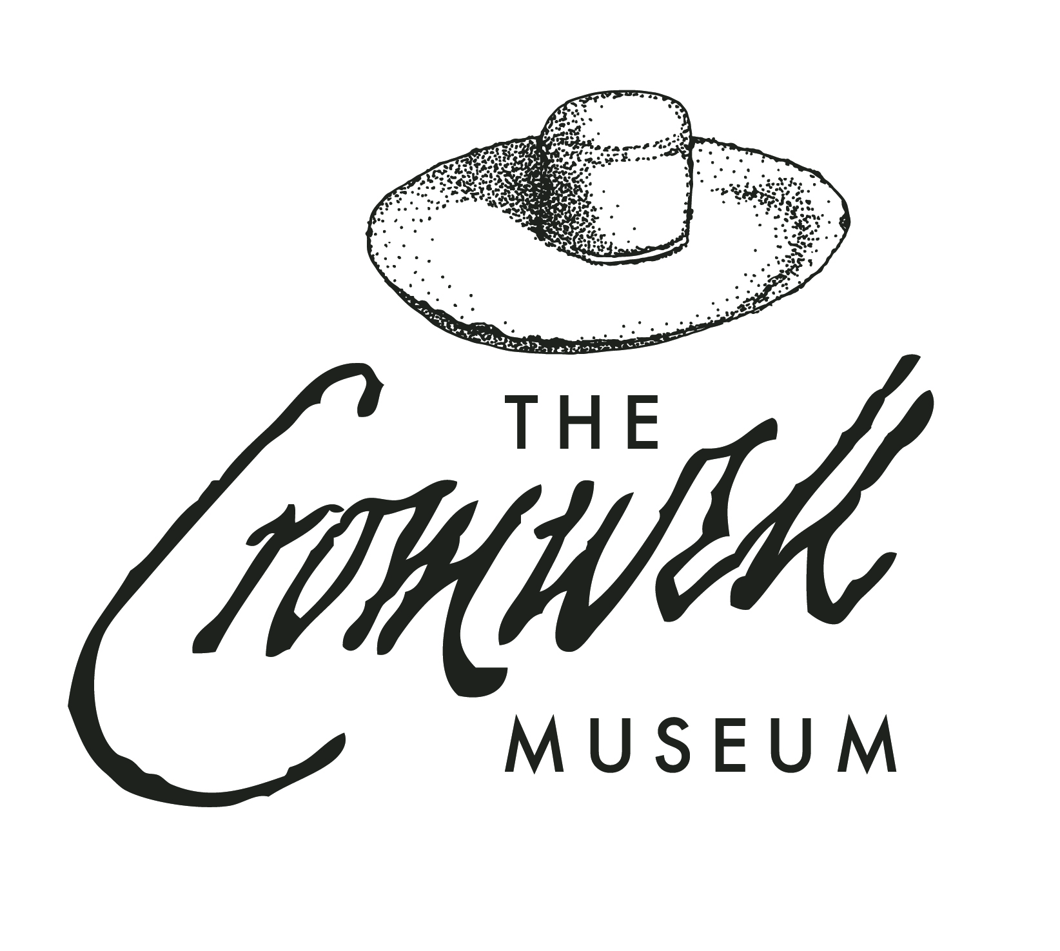 Guided Tour Booking Form
2023 FEEs
£6 per adult,
£5 for seniors, students, u16s
£10 for 2+ tours per person
Minimum Fee £50 (£70 out of hours)

YOUR CONTACT DETAILS

Organiser: Organisation:
Address:
Tel : E-mail :

TOUR DETAILS

Date: Day: Time:

Tour leader: Contact mobile number:

Number in group: Description of group (e.g. school, local history):

Foreign language requirement (if any):

Please specify any special needs (e.g. seating required, wheelchair access):

Tour required: (circle which): Cromwell Museum & Town Hall Historic/Cromwell’s Huntingdon

Signed (Organiser): Date:

Tour Details

We offer three tour elements, each lasting about 30 minutes. For groups we offer a tour of the Cromwell Museum and its collections, followed by the Town Hall including the 18th century Assembly Room and Law Courts. We offer a separate walking tour for an extra charge of the key historic buildings and sites associated with Cromwell around historic Huntingdon. Our tours are accessible for wheelchairs, and all three have a maximum of 18 people per tour. For larger tour groups we can split your group and rotate them between the Town Hall and Museums.

Cancellations and Delays
A cancellation charge of 50% of the cost of the guided tour is charged if cancelled less than 14 days before the tour; the full cost of the tour is payable if cancelled less than 7 days before the tour. Please phone the Museum on (01480) 708008 if you are delayed; guides will usually wait up to 30 minutes. If this period is exceeded without contact from the organiser to inform us as to the delay, the tour may be cancelled, a cancellation fee charged or the tour shortened at the guide’s discretion.

Getting to us
Coaches may drop off/pick up the group in Huntingdon Bus Station, less than 2 minutes’ walk from the Museum and Town Hall. The nearest car park is just behind the Museum on St Germain Street (pay and display). The Museum is about 8 minutes’ walk from Huntingdon Railway Station, which is on the East Coast line with regular trains from King’s Cross and Peterborough.

Other Facilities
Toilets (including accessible toilets) are available in the Town Hall. By prior arrangement we can hold baggage for groups at the Town Hall during your tour. There are many cafes, restaurants, pubs and hotels in the immediate area of the Museum for refreshments – please contact us for more details.

Please return completed form to:
The Cromwell Museum, Grammar School Walk, Huntingdon, PE29 3LF
E-mail: learning@cromwellmuseum.com

